**Marking as Date Table**

In previous demo you imported a dimension table named **DimDate**. While in your model this table is named DimDate, it can also be known as a *Date table*, in that it contains date and time data.

Whenever you use DAX time-intelligence functions, like when you create measures later, you must specify properties which include a *Date table* and a unique identifier *Date column* in that table. In this demo, you mark the **DimDate** table as the *Date table* and the **Date** column (in the Date table) as the *Date column* (unique identifier).

Before you mark the date table and date column, it's a good time to do a little housekeeping to make your model easier to understand. Notice in the DimDate table a column named **FullDateAlternateKey**. This column contains one row for every day in each calendar year included in the table. You use this column a lot in measure formulas and in reports. But, FullDateAlternateKey isn't really a good identifier for this column. You rename it to **Date**, making it easier to identify and include in formulas. Whenever possible, it's a good idea to rename objects like tables and columns to make them easier to identify in SSDT and client reporting applications.

### **Renaming the FullDateAlternateKey column**

### In the model designer, click the **DimDate** table.Double-click the header for the **FullDateAlternateKey** column, and then rename it to **Date**.

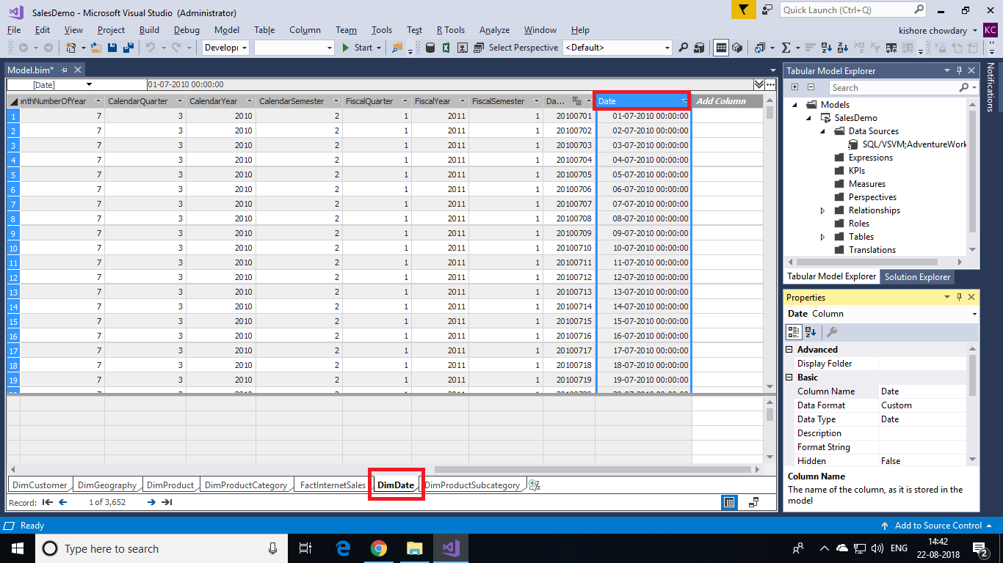

### **Setting Mark as Date Table**

* Select the **Date** column, and then in the **Properties** window, under **Data Type**, make sure **Date** is selected.
* Click the **Table** menu, then click **Date**, and then click **Mark as Date Table**.

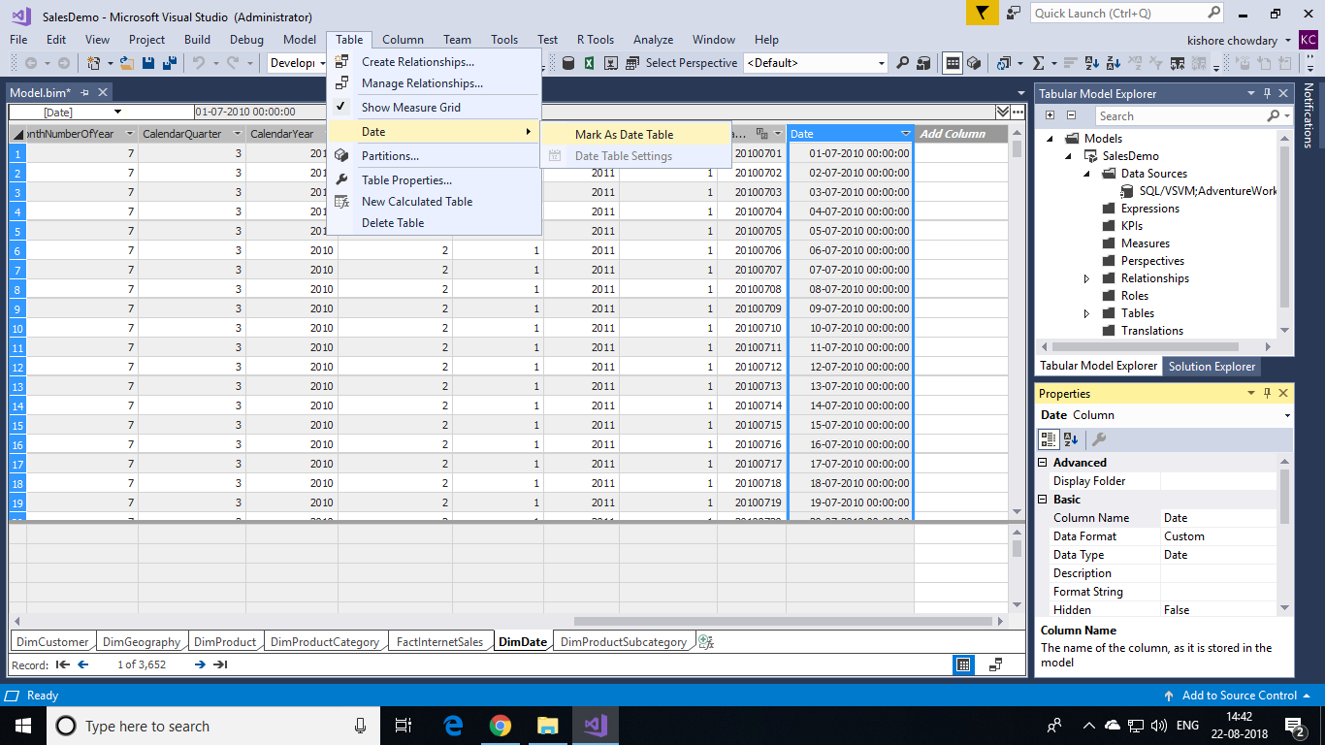

* In the **Mark as Date Table** dialog box, in the **Date** listbox, select the **Date** column as the unique identifier. It's usually selected by default. Click **OK**.

